Student’s name | …………………………………………………….…… | Grade | 2
Subject | Computer | Week No. | 2
Lesson Title | Manage Files and Folders | Unit
Worksheet No. ( 2 ) (Answer)

Instruction: Match the following

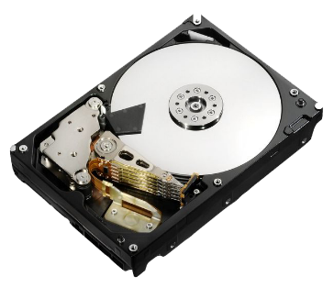 | Folder
 | Hard Disk
 | C: Drive
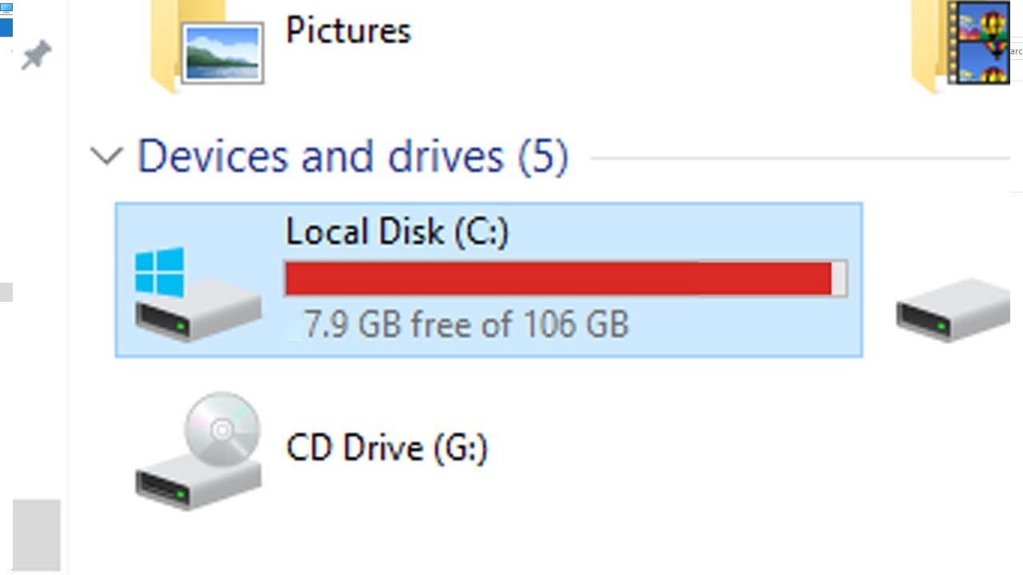 | File

Good Luck

